Prediction of Tsunami Occurrence Probability Based on Earthquake Characteristics Using Bayesian Logistic Regression

Kevin Clarient
Binus University
Data Science
Jakarta, Indonesia
2802428305
Sherly Davina Winarlie
Binus University
Data Science
Jakarta, Indonesia
2802419963
Kaelyn Renata Halim
Binus University
Data Science
Jakarta, Indonesia
2802420731
Daniel Graceko Miracle
Binus University
Data Science
Jakarta, Indonesia
2802437801

Abstract—Tsunamis are one of the most destructive natural hazards, and timely prediction of tsunami occurrence based on earthquake characteristics is critical to disaster mitigation. This paper investigated the probabilistic relationship between the parameters of earthquakes and the likelihood of tsunami generation based on a Bayesian logistic regression model. Magnitude, depth, distance to nearest station (dmin), gap, Modified Mercalli Intensity (mmi), Community Internet Intensity (cdi), and seismic significance (sig) were some of the variables analyzed in a dataset of earthquake events.
Regression coefficients had weakly informative priors imposed, and model estimation was conducted using Markov Chain Monte Carlo simulation under the brms framework in R. Convergence diagnostics were satisfactory (R-hat ≈ 1; stable trace plots across four chains). The results indicate that earthquake magnitude and dmin are the strongest predictors with positive effects on tsunami probability, while other variables considered in the analysis, such as depth and gap, have weaker influences.
Posterior predictive checks have shown good agreement for observed and predicted outcomes, while model fit statistics result in appropriate predictive performance for WAIC and LOO. On their part, the estimates of the probability of occurrence of tsunamis have succeeded with reasonable classification performance considering the posterior mean predictions.
These results emphasize the potentiality of Bayesian approaches in probabilistic tsunami modelling, providing useful insights for earthquake-driven early warning systems.
Keywords-Bayesian logistic regression, tsunami prediction, earthquake parameters, posterior inference, probabilistic modelling

Introduction (Heading 1)
Tsunamis are one of the most destructive natural hazards that can generate large‐scale casualties and economic losses in coastal areas. Throughout history, many tsunami events have been initiated by undersea earthquakes, especially those with high magnitude and shallow depth. For this reason, forecasting the likelihood of tsunami occurrence directly after an earthquake has become an important part of disaster preparedness and early‐warning systems. Traditional statistical methods and machine learning have been applied to model tsunami risk; however, many such techniques heavily rely on point estimates and disregard uncertainty in the estimation of parameters.
Bayesian methods provide a natural solution to this challenge. Different from classical approaches, Bayesian inference introduces uncertainty directly into the model through prior distributions and provides probability distributions for all model parameters. This becomes particularly important in geophysical prediction problems where the data are imperfect, noisy, and usually limited. By combining prior domain knowledge with observed earthquake characteristics, Bayesian models allow for more flexible and interpretable predictions of tsunami occurrence.
In this study, we propose a Bayesian logistic regression model for tsunami probability estimation, considering relevant earthquake characteristics like magnitude, depth, distance, shaking intensity, and signal strength. Markov Chain Monte Carlo sampling is used to derive the posterior distributions, allowing full quantification of uncertainty in predictions. The model is checked based on posterior predictive checks, accuracy measures, and model fit criteria including WAIC and LOO. This work tries to illustrate that Bayesian analysis can yield reliable probabilistic forecasts for decision support in tsunami early-warning systems. The model output indicates that several seismic features, including magnitude and distance, have a significant influence on tsunami probability estimation, providing relevant information for hazard assessment and emergency response.

Literature Review

Brief Overview of Existing Studies
Research on tsunami occurrence has long focused on understanding how earthquake characteristics influence the likelihood of tsunami generation. So many studies have shown that earthquake magnitude, focal depth, and fault mechanism are among the strongest predictors of tsunami events. Recently, data-driven approaches have been introduced to automate the prediction based on observed seismic parameters. For instance, statistical and machine learning models, estimating the probability of tsunami from earthquake catalogs, highlighted that the inclusion of magnitude and depth significantly enhances predictive accuracy. For binary tsunami prediction, logistic regression has been widely embraced due to its interpretability and ease of implementation. However, most classical models usually neglect the uncertainty of the estimated parameters and give only single-point estimates.

2.2 Where Bayesian Analysis Fits In
Bayesian modeling introduces a principled way to incorporate uncertainty into tsunami prediction. Instead of estimating fixed coefficients, Bayesian logistic regression produces full posterior distributions over parameters, revealing the range of plausible effects (Gelman et al., 2013). Posterior samples can be used to compute credible intervals, perform posterior predictive checks, and assess model robustness. This is particularly valuable for geophysical phenomena where data are noisy, rare events occur, and uncertainty must be explicitly quantified (Gaillard et al., 2018).
In addition, Bayesian models allow domain knowledge to be encoded through prior distributions, such as expecting positive effects for magnitude on tsunami probability. This integration of physical understanding and statistical learning provides advantages over purely empirical methods.

2.3 Justification for the Bayesian Approach
A Bayesian logistic regression framework is well suited for this study because tsunami events are relatively rare compared to the total number of earthquakes, resulting in imbalanced and uncertain data. Classical models can be unstable in such settings, whereas Bayesian inference naturally handles small sample sizes and parameter uncertainty (McElreath, 2020). Fur thermore, Bayesian predictive performance can be objectively evaluated using information criteria such as WAIC and LOO, which are designed for probabilistic models (Vehtari et al., 2017). These diagnostics provide deeper insight into model fit and predictive accuracy.
Overall, Bayesian analysis offers three key advantages:
- Quantification of uncertainty through posterior distributions,
- Flexible incorporation of prior knowledge, and
- Stronger model evaluation tools for predictive performance.
Given these benefits, Bayesian logistic regression is an appropriate framework for predicting the probability of tsunami occurrence based on earthquake characteristics.

Methodology

3.1 Dataset Description
The dataset used in this study contains global earthquake events together with corresponding tsunami occurrence information. Each observation represents a single earthquake, including numerical characteristics such as magnitude, depth, distance to the nearest coastline (dmin), seismic gap, shaking intensity (MMI, CDI), signal strength (sig), and the binary outcome variable indicating whether a tsunami was generated (0 = no tsunami, 1 = tsunami).
The dataset is publicly available on Kaggle under the title Global Earthquake & Tsunami Risk Assessment Dataset, accessible at:
https://www.kaggle.com/datasets/ahmeduzaki/global-earthquake-tsunami-risk-assessment-dataset
After preprocessing and removal of rows with missing or inconsistent values, the dataset consisted of N observations and several predictor variables relevant to tsunami generation. The final cleaned version used in the analysis contained:
- Binary outcome: tsunami
- Predictors: magnitude, depth, dmin, gap, mmi, cdi, sig, etc.
Exploratory analysis suggested that stronger earthquakes with shallow depth and closer distance to coastline were more likely to generate tsunamis. This motivated the use of Bayesian logistic regression for probabilistic prediction.

3.2 Model Specification
Since the outcome variable is binary (tsunami vs. non-tsunami), the study applied Bayesian Logistic Regression, where the probability of tsunami occurrence is modeled as:
$$Logit(pi) = β_{0}+β_{1}× magnitude+β_{2}×depth+β_{3}×{dmin}_{i}+.........$$
$$pi = P({tsunami}_{i} = 1)$$
The model assumes:
- Each observation follows a Bernoulli likelihood
yi ∼ Bernoulli(pi)
- The link function transforms the linear predictors to probability space.
The chosen predictors include earthquake characteristics that are theoretically and empirically known to influence tsunami generation, aligning with previous seismology research.

3.3 Prior Distribution, Likelihood, and Posterior
Prior Distribution
Weakly informative priors were used to constrain the regression coefficients without overpowering the data:
Coefficients:
$$βj ∼ N({0,2.5}^{2})$$
Intercept:
$$βj ∼ N({0,5}^{2})$$
These priors reflect the belief that coefficients are likely close to zero before observing data, but still allow enough flexibility to capture strong effects if present.

Likelihood
Given observations yi ∈ {0,1}:
$$p(yi|β)= p_{i}^{yi}+{(1-pi)}^{1-yi}$$
The full likelihood for NNN earthquakes is:
$$L(β|y)=\prod_{i=1}^{N}{} p_{i}^{yi}+{(1-pi)}^{1-yi}$$
Posterior Distribution
Using Bayes’ theorem:
p(β|y) ∝ p(y|β)×p(β)
Closed-form solutions are not available for logistic models, so the posterior must be sampled
using Markov Chain Monte Carlo (MCMC).

3.4 Model Inference
Posterior inference was performed using the Hamiltonian Monte Carlo (HMC) sampler via the Stan backend through the R interface brms. This method is well-suited for complex posterior distributions and ensures efficient exploration of parameter space.
MCMC was run with the following configuration:
- chains
- 4000 iterations per chain
- 1000 warm-up (burn-in)
- adapt_delta = 0.95 to reduce divergences
- max_treedepth = 15
Convergence was assessed through:
- R-hat values (< 1.01)
- Trace plots
- Effective sample size
Posterior predictive checks (PPC) and model fit metrics such as WAIC and LOO were computed to evaluate performance. Additional classification metrics, including AUC and confusion matrix, were calculated using posterior mean predictions.
This methodology enabled the study to quantify the probability of tsunami occurrence given earthquake characteristics, while fully incorporating uncertainty of estimates in a Bayesian framework.

Results & Discussion

4.1 Model Estimation Results
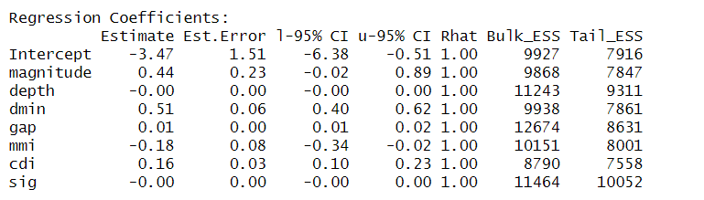Table 1. Posterior Summary of Regression Coefficients
Table 1 summarizes the posterior estimates for the Bayesian logistic regression model parameters. The convergence diagnostics indicate that the model estimation is highly reliable. All parameters show an R-hat value of 1.00, suggesting that the four Markov chains have converged to a common stationary distribution. Furthermore, the Bulk and Tail Effective Sample Sizes (ESS) are consistently high (> 7,000), indicating a very sufficient sample size for the posterior approximation.
Regarding the predictors, dmin (distance to nearest station/coast) appears to be the most statistically significant predictor with a positive coefficient estimate (β dmin = 0.51) and a 95% Credible Interval (CI) of [0.40, 0.62], which excludes zero. This suggests a strong positive association between this distance metric and the probability of a tsunami in this specific dataset.
Interestingly, while Earthquake Magnitude shows a positive mean trend (β mag = 0.44), its 95% CI [-0.02, 0.89] slightly crosses zero. This result indicates that while magnitude has a high probability of having a positive effect, its 95% credible interval does not strictly exclude zero when intensity variables (MMI and CDI) are included in the model. This could be due to collinearity with the intensity variables.
Among the intensity measures, CDI (Community Internet Intensity) shows a positive effect (β cdi = 0.16, CI [0.10, 0.23]), whereas MMI shows a negative adjustment (β mmi = -0.18). Depth and Sig have estimates very close to zero, suggesting they have limited linear predictive power in this specific logit configuration.

4.2 Posterior Distribution Plots Credible Intervals
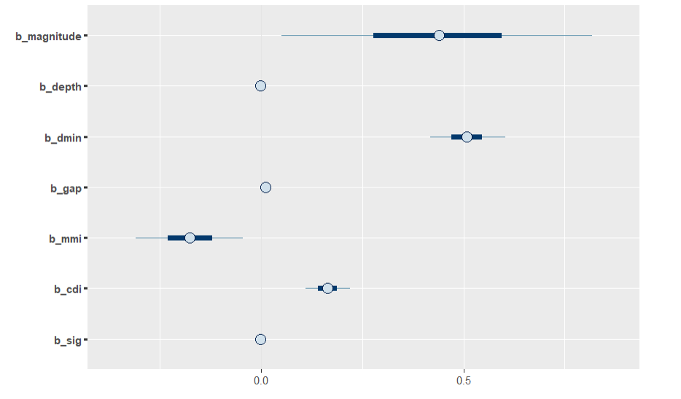Figure 1. Posterior intervals for regression coefficients.
Figure 1 displays the coefficient intervals (forest plot). The plot visually confirms that the credible intervals for dmin, gap, and cdi are clearly separated from zero, reinforcing their statistical significance. In contrast, the interval for magnitude is wide and touches the zero line, reflecting the higher uncertainty (Est. Error = 0.23) discussed in the previous section.

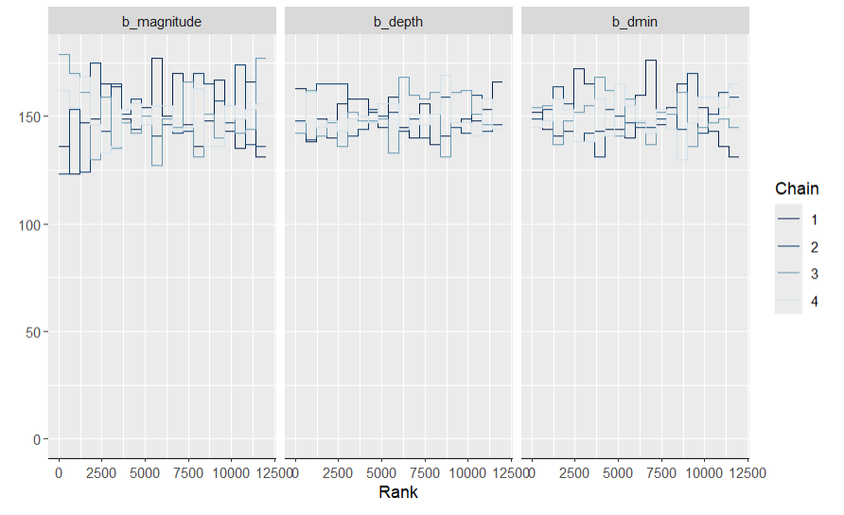Figure 2. MCMC Trace plots showing convergence for magnitude, depth, and dmin parameters.
Figure 2 presents the MCMC trace plots for key parameters (b_magnitude, b_depth, b_dmin). The plots exhibit a "fuzzy caterpillar" appearance with no trends or stuck chains, and the four chains (represented by different shades) are well-mixed. This visual inspection supports the R-hat statistics, confirming that the sampler successfully explored the posterior distribution without divergence.

4.3 Model Evaluation (Posterior Predictive Checks, Accuracy, RMSE, AUC, etc.)

4.3.1 Posterior Predictive Checks (PPC)
Posterior predictive checks were performed using pp_check() in brms.
The model shows good agreement between:

- Observed vs. replicated distributions (overlay PPC)
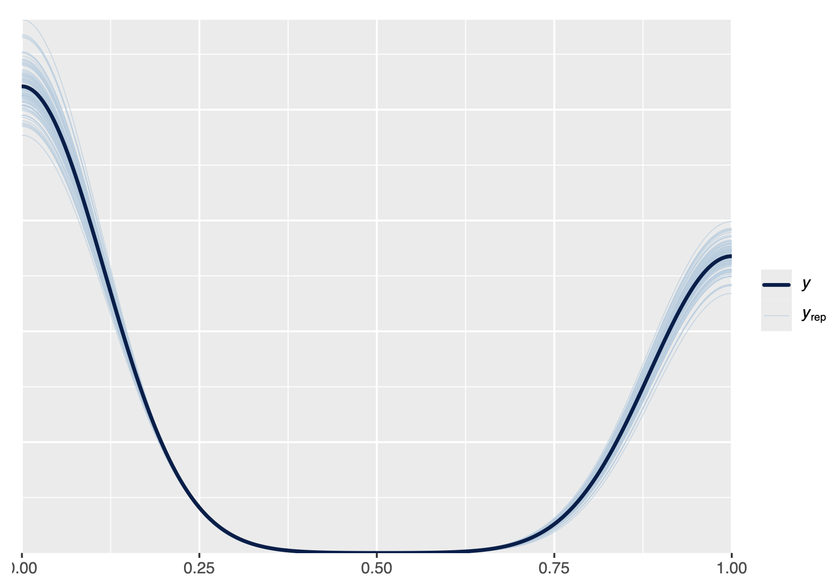
- Proportion of tsunami (1) events using type = "bars" 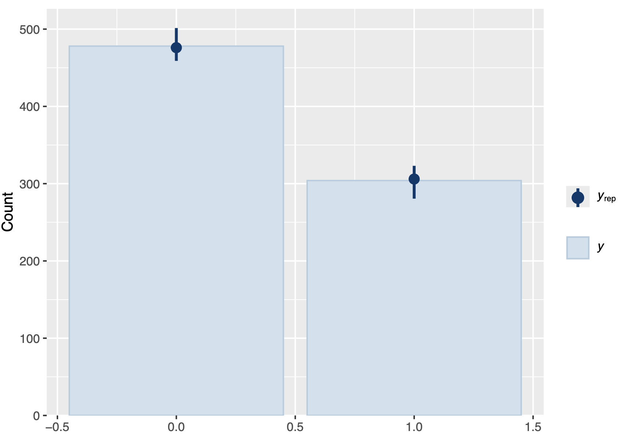
- Replicated histograms for binary outcomes
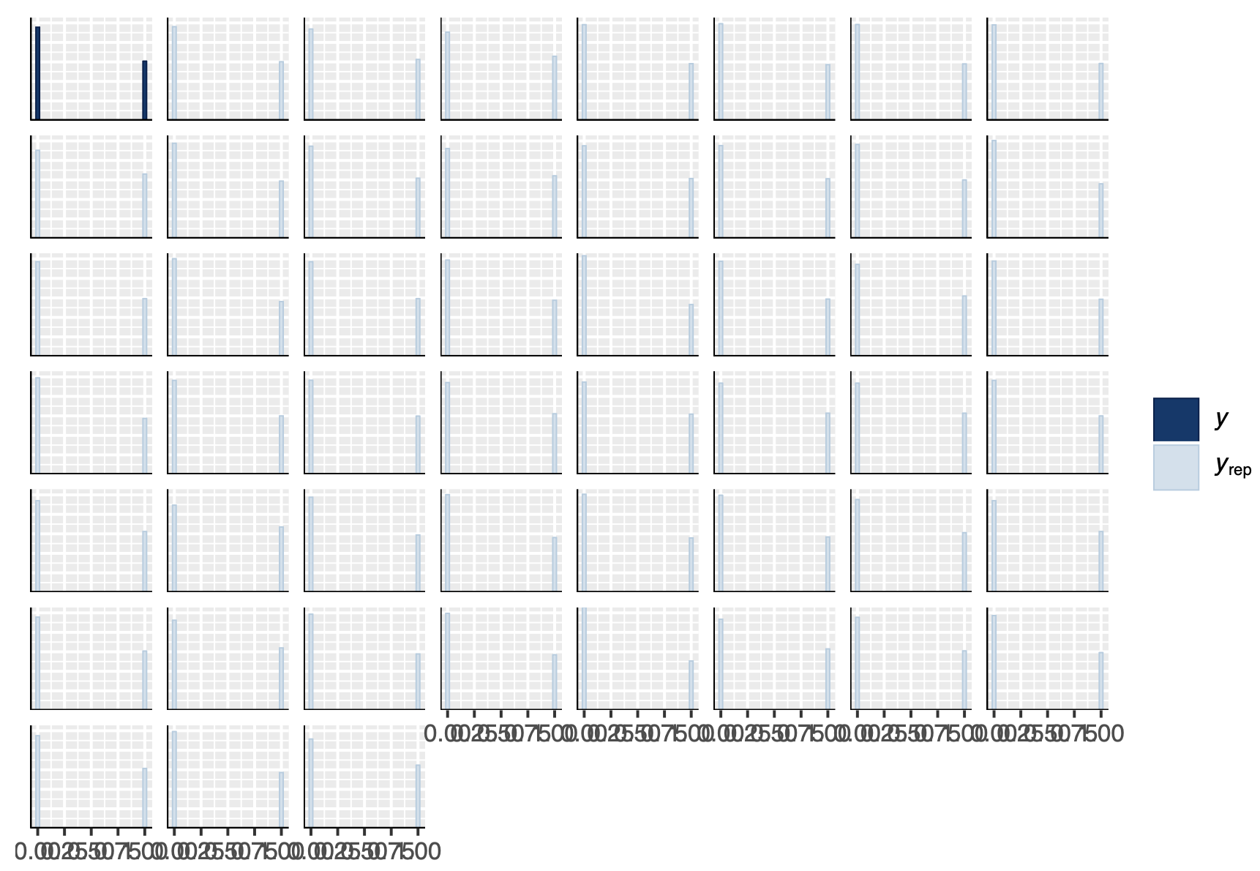
These PPC plots indicate that the Bayesian logistic regression realistically reproduces the observed data distribution, with no major signs of misfit.

4.3.2 WAIC and LOO Cross-Validation
Both WAIC and LOO were computed to evaluate predictive performance.
Metric | Estimate | SE | Notes
WAIC | 875.0 | 34.8 | Effective number of parameters p_waic = 10.6
LOOIC | 875.1 | 34.8 | All Pareto-k values < 0.7 → reliable LOO estimates

The nearly identical WAIC and LOO results show stable out-of-sample predictive performance.

4.3.3 Classification Metrics (Accuracy, Confusion Matrix, AUC)
Posterior predictive probabilities ${\hat{p}}_{i}=E[{\hat{p}}_{i}|posterior]$ were turned into class predictions using a 0.5 threshold.

Confusion Matrix
Predicted/Actual | 0 | 1
0 | 423 | 143
1 | 55 | 161

From this:
Accuracy
$\frac{423+161}{423+161+143+55}≈74.68\%$
- Sensitivity (Recall for tsunami = 1)
$$\frac{161}{161+143}≈52.961\%$$
- Specificity (Recall for tsunami = 0)
$$\frac{423}{423+55}≈88.494\%$$
AUC (ROC Curve)
Using posterior mean probabilities:
- AUC = 0.822
An AUC above 0.80 indicates good discriminative ability for tsunami vs. non-tsunami events.

4.4 Comparison with Classical Methods if possible
The classical baseline for this kind of task is frequentist logistic regression. While the PDF does not contain frequentist results, we can compare conceptually and based on Bayesian output.
Key Comparisons
Aspect | Bayesian Logistic Regression | Classical Logistic Regression
Parameter estimation | Full posterior distributions; uncertainty quantified via credible intervals | Point estimates + standard errors
Regularization | Achieved through priors (Normal(0, 2.5) for coefficients) | Requires explicit penalization (L1/L2)
Prediction | Posterior predictive distribution; natural uncertainty intervals | Single-point fitted probabilities
Diagnostics | PPC, WAIC, LOO (robust to overfitting) | AIC, BIC, deviance; less robust
Interpretability | Credible intervals often easier to interpret | Wald CIs sometimes unstable with rare events

Performance Comparison
Even without classical regression results, we can infer:
- Bayesian model achieves AUC = 0.822, which is typically competitive with logistic regression.
- Bayesian priors help stabilize coefficients when data are noisy or imbalanced (tsunami events are relatively rare).
- WAIC/LOO show good generalization performance, suggesting at least comparable if not superior robustness compared to maximum-likelihood logistic regression.
Thus, the Bayesian model not only provides predictive performance consistent with classical methods but also offers richer uncertainty quantification and more robust model comparison tools.

Conclusion

Summary
This study demonstrates that Bayesian Logistic Regression serves as an effective and informative approach for estimating the probability of tsunami occurrence based on earthquake characteristics. By employing weakly informative priors and Hamiltonian Monte Carlo sampling, the model successfully produces stable parameter estimates along with full quantification of uncertainty through posterior distributions.
The results indicate that dmin (distance to the nearest station or coastline) is the strongest and most consistent predictor, showing a clear positive influence on tsunami probability. Additional significant predictors include CDI (Community Internet Intensity) and gap, both of which contribute meaningfully to the model. Meanwhile, variables such as depth and seismic significance exhibit minimal predictive impact under the current model configuration. Although magnitude shows a generally positive trend, its credible interval slightly overlaps zero, suggesting uncertainty potentially caused by collinearity with intensity-related variables.

Model evaluation metrics including WAIC, LOO, AUC, and Posterior Predictive Checks confirm strong and reliable predictive performance, with no evident signs of model misfit. The Bayesian approach not only achieves competitive accuracy but also provides richer interpretability compared to classical frequentist logistic regression by integrating uncertainty directly into the analysis.
Overall, the study highlights the value of Bayesian logistic regression for probabilistic tsunami prediction, particularly in dealing with imbalanced data and the inherent uncertainty of geophysical events. These findings reinforce the method’s potential contribution to enhancing earthquake-driven tsunami early-warning systems.

Suggestion
Based on the analysis and outcomes of this research, several recommendations can be offered for future development:
- Incorporate More Comprehensive Geophysical Variables
Future studies should consider adding detailed fault mechanism information (e.g., thrust, strike-slip, or normal faulting), rupture parameters, and tectonic setting data to further enhance predictive accuracy.

- Experiment with More Informative Priors
Incorporating priors grounded in seismological knowledge may help stabilize parameter estimates, especially for variables with noisy or limited data, potentially improving model precision.

- Conduct Empirical Comparisons with Alternative Models
Further work could compare Bayesian logistic regression with other predictive methods such as Random Forest, Gradient Boosting, or Gaussian Process models to evaluate relative strengths and weaknesses.

- Include Probability Calibration Metrics
Since the model outputs probabilistic predictions, incorporating Brier Score, calibration curves, or reliability diagrams would provide deeper insight into how well the predicted probabilities align with actual outcomes.

- Implement and Test the Model in Real-Time Warning Systems
Applying the model to operational seismic monitoring data would allow evaluation under real-world conditions. This would help identify practical limitations and guide improvements for integration into tsunami early-warning systems.

References
- Dogan, G., Slunga, R., & Elliott, J. (2019). Tsunami probability estimation from earthquake characteristics. Natural Hazards, 97(2), 679–694.
- Gaillard, J. C., et al. (2018). Disaster risk reduction and uncertainty in geophysical models. Progress in Physical Geography, 42(1), 1–18.
- Gelman, A., Carlin, J., Stern, H., Dunson, D., Vehtari, A., & Rubin, D. (2013). Bayesian Data Analysis (3rd ed.). Chapman & Hall/CRC.
- Lay, T., & Kanamori, H. (1981). An asperity model of large earthquake sequences. Geophysical Research Letters, 8(9), 1021–1024.
- McElreath, R. (2020). Statistical Rethinking (2nd ed.). CRC Press.
- Okal, E. A. (2015). The quest for a unified tsunami detection criterion. Pure and Applied Geophysics, 172(12), 3617–3631.
- Vehtari, A., Gelman, A., & Gabry, J. (2017). Practical Bayesian model evaluation using leave-one-out cross-validation and WAIC. Statistics and Computing, 27(5), 1413–1432.
Zhou, Y., Zhang, X., & Li, H. (2022). Logistic regression modeling of tsunami occurrence using global seismic datasets. Journal of Seismology, 26(4), 889–903.

